M/V MANATEE AMAZON EXPLORER
5 DAYS / 4 NIGHTS ITINERARY
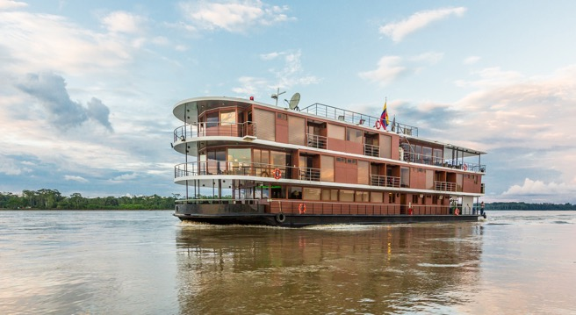
MONDAY – FRIDAY

EXPLORING THE AMAZON
This is a journey that takes us into the endless heart of biodiversity, the Amazon Basin. Given the remote and pristine nature of this jungle, the very best way to explore it is by navigating down the Napo River on exclusively - designed vessel set to explore the Amazon in style.

The M/V Manatee Amazon Explorer allows our guests to experience unparalleled adventures in total comfort. Journey with us down freshwater rivers, both whitewater and black water, and encounter different Amazonian ecosystems, including the possibility to observe fascinating animals such as pink river dolphins, manatees, caimans and piranhas, as well as hundreds of native bird and primate species.

These amazing adventures are possible on board our exclusive vessel featuring: 10 Standard Cabins, which offer air conditioning, balconies and ceiling-to-floor windows, and private bathrooms with hot water, and our 4 Deluxe Cabins which come complete with all of the above, plus private balconies and private whirlpool bathtubs with a scenic view! Make yourself at home with our complete range of onboard amenities! We have a comfortable bar and lounge, conference room a cozy reading room, a rainforest spa, a explorer´s boutique, an al fresco lounge and dining room providing exceptional culinary offerings to our guests, and even an outdoor hot tub on the observation deck! We want to ensure that you enjoy the perfect rainforest journey in full comfort, navigating deep into the heart of one of the new seven wonders of the natural world – the Amazon.

We are committed to caring for natural resources and the conservation of local cultures by applying responsible and sustainable tourism practices and community involvement in all of our operations. We have also initiated Capi’s Amazon River Station (CARS). This is a program that manages 3 non-profit sustainable rescue projects for endangered animals in the Ecuadorian Amazon Rainforest: The Charapas turtle, the Pink River Dolphin, and the Manatee.

ACTIVITIES AND ADVENTURES:
- Swimming
- Kayaking
- Birdwatching
- Jungle Hikes
- Canoe Excursions
- Cooking Lessons – Traditional Dishes
- Climbing the Observation Tower high in the Amazon canopy
- Native Family Visit
- Night Hikes
- Briefings given by Expert Naturalist Guides
- Demonstration of Regional Handicrafts
- BBQ Pit
- Traditional Amazonian Delicacies
- Camping (5 & 8 days Itineraries)

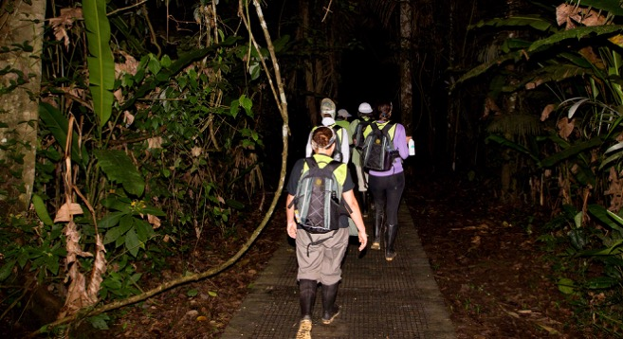
DAY 1 - MONDAY: QUITO – COCA – NAPO RIVER

Our adventure begins in the city of Quito, Capital of Ecuador. After taking a short 30- minute flight from Quito to the Amazon city of Coca, located in the Province of San Francisco de Orellana, we will transfer to the dock and board our motorized canoe to begin our journey down the river for approximately an hour and a half, taking in the first sights and sounds of the Amazon. Soon, we will reach the M/V Manatee Amazon Explorer and receive our welcome aboard.

Once we have settled into the M/V Manatee Amazon Explorer, we will be joined by expert local naturalist guides who will provide us with a brief and informative introduction to the Ecuadorian Amazon, after which guests will have their first opportunity to discover the exciting features of our cruise ship: spacious social areas, comfortable suites, and the observation deck that allows us to admire the changing rainforest landscape as we glide down the Napo River.

After dinner, we will plunge straight into the Amazon by going for a nighttime forest walk to observe the forest’s nocturnal activity and experience the thrill of the vivid noises and aromas that come from so much biodiversity.

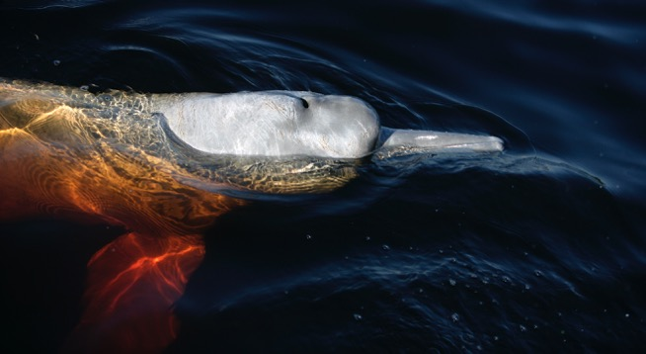
DAY 2 - TUESDAY: THE HEART OF YASUNI NATIONAL PARK (HOME OF THE LEGENDARY PINK RIVER DOLPHIN)

Early in the morning, we will visit Yasuni National Park. This is a pristine and relatively undisturbed region of the Ecuadorian Amazon. Our guests will be pleased to learn that this is the home of the legendary Pink River Dolphin! In this area we can also find anacondas, river turtles and various primate species, as well as the colorful Hoatzin, a unique bird that is known locally as the “Stinky Turkey”.

Later in the afternoon, we will go canoeing in a blackwater lake, home to giant otters and the magnificent, albeit elusive manatee. We will also enjoy a pleasant hike in the Riparian/Gallery Forest, where we have the chance to spot a flock of birds and marvel at the intricate organization of a colony of leaf-cutter ants by the “Giant Fig Tree”, a truly majestic tree that is home to an abundance of wildlife, much like the “Giant Kapok Tree”.

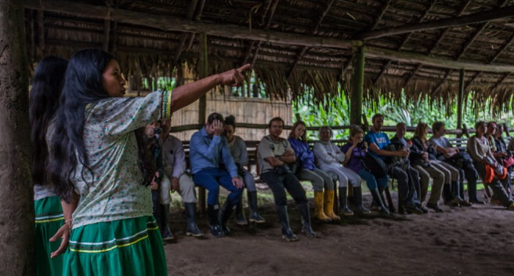
DAY 3 - WEDNESDAY: QUECHUA FAMILY & CANOEING IN A BLACKWATER LAKE

We will start the day off by visiting an authentic Quechua family located on the banks of the Napo River, where we will receive cultural immersion and the opportunity to learn directly from members of the local community.

We will then board the M/V Manatee Amazon Explorer for lunch and some leisure time as we continue our journey upstream. At this time, our guests are invited to participate in a cooking class with our chef who will share recipes and techniques for preparing exquisite traditional Ecuadorian food that you can replicate at home. Guests are also invited to try their hands at making traditional handicrafts.

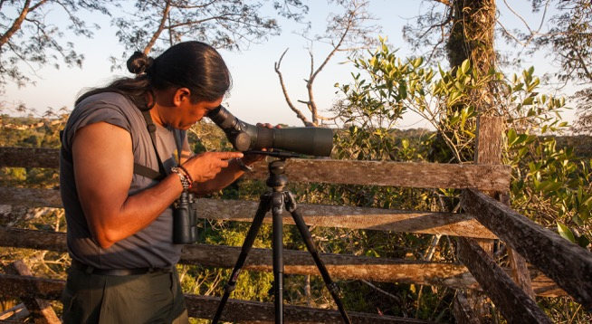
DAY 4 - THURSDAY: FOREST ADVENTURE & OBSERVATION CANOPY TOWER

Our guests can relax and enjoy the M/V Manatee Amazon Explorer during the morning and disembark to explore the nearby forest for a walk to discover a myriad of different animals and plant species that can only be found in the Amazon basin.

In the afternoon, we will visit a canopy tower, built against a giant Kapok tree. The perspective at the top of this observation tower is truly glorious, looming above the lush treetops and providing a view of the sheer vastness of the Amazon Basin.

In the evening, we will bravely venture into the river on a canoe to search for black caimans with the help of our flashlights.

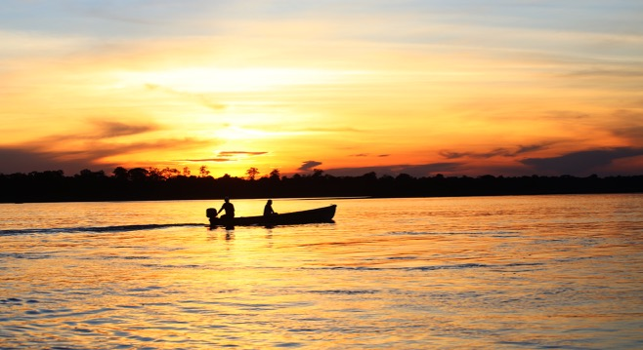
DAY 5 - FRIDAY: RETURN

This is where our adventure ends! Enjoy the last part of our return journey onboard and then disembark the M/V Manatee Amazon Explorer to take the motorized canoe back to Coca (one-and-a-half-hour ride).

*For our guests with a more adventurous inclination, we are pleased to offer a camping program, which is an alternative manner to explore this enchanting destination. Contact us for more details! (Optional activity for the 5 & 8 days Itinerary)

NOTE: The foregoing itinerary is our standard operating model. We intend to offer everything as planned, and will make every effort to do so, however depending on inclement weather, technical or operational difficulties beyond our control, the M/V Manatee Amazon Explorer reserves the right to modify the itinerary without notice.

OUR PROGRAM INCLUDES:
  - Transportation to and from Coca airport and M/V Manatee Amazon Explorer.
  - Onboard Accommodation
  - Scheduled visits according to the itinerary with a certified naturalist guide.
  - Unlimited supply of hot water, coffee and tea.
  - All meals on board.

OUR PROGRAM DOES NOT INCLUDE:
  - Air Ticket Quito - Coca - Quito ($200 per person). (The rates include private & personalized assistance for Quito – Coca - Quito flights at both airports. Transfers to/ from the vessels when arriving on our flights. Exclusive access to our VIP Lounge (before and after the cruise), with modern and well-equipped facilities, where we will provide our guests with complementary coffee, tea, water and light snacks)

*Subject to change without notice
  - Admission to local communities and natural reserves (USD 70.00 net per person for 4 & 5 day cruises, USD 80.00 net per person for 8 day cruise)

*Subject to change without notice
  - Transfers to and from Quito’s airport
  - Alcoholic and non-alcoholic beverages.
  - Gratuities
  - Wi-Fi Internet (Due to the remote area of navigation, satellite internet is only available in certain zones and during certain times. Should our guests require this, we are able to offer it for the price of $15 for the entire duration of the cruise).
  - Personal expenses.
  - Other services not specified in the program

PREPARING FOR THE AMAZON

The Ecuadorian Amazon Basin is a special place, teeming with natural life and adventure at every turn. There is no telling what you will see or experience, and the unexpected is most certainly one of its treasures.

Of course, there are constants as well. The Amazon is located in the lowland equatorial tropics. This is a humid environment. Excursions on land usually take place in the mornings and afternoons, as the temperature rises at midday, when we will usually be on board the M/V Manatee Amazon Explorer. Weather is relatively constant throughout the year (we’re on the equator, so there are no strongly demarcated seasons).

This is a rainforest, so rain is a normal occurrence, and is what makes the area so lush and beautiful. Showers are often short-lived and serve to cool the air, which is always welcome and refreshing. The insects here are a unique, colorful and natural part of the environment. Like most everywhere in the world, you’ll find mosquitoes, but you’ll be pleasantly surprised to learn that they are quite manageable with a little repellent from time to time.

Forest trails can be uneven (a sturdy walking stick is helpful if you do not feel that you are steady on your feet), and one can expect to encounter mud and puddles along certain segments. While a good pair of hiking boots with appropriate traction might be helpful, they are not always the best footwear. Usually, you are better off with rubber boots (which we provide onboard, as well as waterproof plastic ponchos). By the way, the clothes you bring along should be lightweight and quick-drying. (Please refer to our packing list below).

When we say that things are unexpected in the Amazon, we really mean it! You just never know what you will encounter and there is always something new. The Amazon is so unique and magical that for those who experience this environment for the very first time, it can prove to be a profound and life-changing experience.

The sound of the forest is unbelievable. When paddling along one of the winding black-water streams, we invite you to close your eyes and try to take in the plethora of fascinating sounds that fill the air. We invite you to slow down, live in the present, and experience the natural beauty and richness all around you… Just let go, enjoy, and allow the spirit of the Amazon to envelope and enthrall you.

PACKING LIST
  - Passport (and a color copy kept in a separate bag)
  - Comfortable walking or tennis shoes
  - Walking stick (optional)
  - Several lightweight pants (more than two)
  - DON’T BRING JEANS!
  - 3 or more long and short-sleeved shirts or blouses
  - Vests with pockets are useful for carrying camera equipment and other accessories
  - A windbreaker or sweater for breezy afternoons
  - Waterproof cotton socks (one pair per day)
  - Small, sturdy umbrella (one)
  - Shorts (at least one pair)
  - T-shirts (at least three)
  - Bathing suit/swimwear
  - Cotton underwear
  - Hat or cap
  - Water bottle
  - Sunscreen lotion
  - Sunglasses
  - A flashlight and extra batteries
  - Binoculars (available on board as a rental item)
  - Small waterproof backpack (available for purchase on board)
  - Insect repellant
  - Camera and extra batteries, enough memory cards
  - Personal first-aid kit
  - Plastic bags for storing wet clothing
  - Your own medications, if applicable. Don’t forget them!
  - Cash – we also accept credit cards on board.

DO’S & DON’T’S
  - Opt for neutral clothing colors and avoid conspicuous clothing in bright colors or white, so as not to distract (or frighten) certain animals. The more you can blend into your surroundings, the better!
  - Make sure your electronic equipment is at least somewhat waterproof or packed in a waterproof bag or pouch, especially if you plan to use it during excursions.
  - Speak softly when on forest trails or canoe trips – loud voices can scare away the wildlife that everyone wants to see.
  - Watch your step and follow the group. Don’t try to get ahead of the guide or tour leader, and avoid lagging behind.
  - Always tell your guide if you see something and don’t hesitate to ask questions. That’s what your guide is there for!
  - Don’t Litter! Respect the forest and its wildlife. Bring a backpack or plastic bag in which you can discard plastic, wrappers, paper, and other waste.
  - With our guides and staff, you are in good hands. You can trust us! We have decades of experience showing guests the wonders of the Amazon. We are not only here to guide you and show you around, but also to take care of you and make you feel at home.
  - Take advantage of as many outings as possible… The adventure lies “out there”. We guarantee that, given the right conditions, every outing we have selected for our itinerary has been customized to offer unique and extraordinary experiences.
  - If you have physical limitations or concerns, do not hesitate to ask our guides if trails and activities are right for you. Most activities don’t require excessive physical effort, but please let us know if you are feeling any discomfort during an outing, and feel free to ask us for more information about what you may encounter during an outing once we have explained what it entails.
  - Don’t hesitate to share your interests and preferences with our staff! It is important to us that you make this adventure your own. We have the ability to offer a certain degree of flexibility in terms of alternatives to our daily activities. Although it is not always possible, we will do what we can to personalize your Amazon cruise experience.

OPERATIONAL TERMS AND CONDITIONS

Medical and Health:
Good physical health is required to best enjoy an Amazon River Cruise. Visitor sites are accessible by small, motorized boats, and will possibly require wet landings. Irregular terrain may be present during hikes and daily nature excursions, and embarking and disembarking occasionally requires a degree of physical effort. Travelers do not require vaccinations for malaria and/or yellow fever, although we recommend you consult your physician.

Dietary Needs:
M/V Manatee Amazon Explorer requires written notification 30 days prior to departures from travelers requesting specific dietary needs. Every effort will be made to cater to these dietary needs, as long as the products are available in Ecuador.

Insurance:
We strongly recommend that you plan to arrive in Quito an extra day before cruise departure, given that no refunds are applicable in the unlikely event that weather-related flight cancellations cause you to miss your embarkation. Flight cancellation is beyond our control and as a cruise operator; we must adhere to strict operating standards, which include our schedules. We advise travelers to purchase trip cancellation insurance, to reimburse the cost of air tickets and other non-refundable fees incurred during trip reservations in the event of unexpected cancellations. Standard International medical, baggage loss, and airline delay insurance are also recommended.

Vessel Replacement:
M/V Manatee Amazon Explorer reserves the right to replace the cruise vessel when required (i.e., force majeure or inclement weather). Should travelers not agree to the adjustment, M/V Manatee Amazon Explorer reserves the right to cancel the trip, offering a pro-rata refund per cruise night not used or, alternatively, offer a credit toward a future cruise onboard the M/V Manatee Amazon Explorer.

Visits to the Amazon Communities and Natural Reserves:
A portion of our excursions take place within protected areas, and visitors are required to comply with these area’s rules and regulations. Naturalist guides will inform guests about these rules. M/V Manatee Amazon Explorer, represented by its onboard guides, reserves the right to deny access to any guest who ignores, violates or is unable to comply with these regulations. We appreciate your understanding.

